Monday 1st July 2019

Storytelling week – 1st-5th July 2019

Dear Parents/Carers
This week we are learning about languages and stories from around the world.
We would like to invite you to read or tell a story or a legend from your home country to your child’s class. This can be done in your home language if you wish where picture books are used.
Please come and speak to your class teacher if you would like to volunteer your time to discuss when you can come and tell your story.
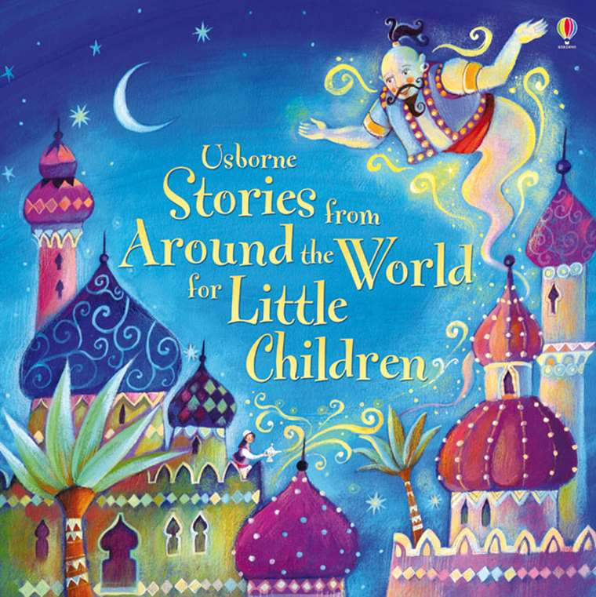
Yours sincerely

Ms Lindner & Ms Miles
Reception Class Teachers

