Friday 30th June 2017

The Lion King Musical Trip

Dear Parent/Carer

We have arranged for Year 6 pupils to visit the Lyceum Theatre (Wellington Street, WC2E 7RQ) to see Disney's multi award-winning musical, The Lion King on Wednesday 5th July 2017. Currently we have a limited number of spare tickets available for sale so we are now extending this opportunity to Y4 and Y5. If you are interested in purchasing a ticket for your child please register your interest on the reply slip below and return it to the school office by Monday 3rd July. Successful applicants will then be advised by Monday 3rd July.

We will travel by public transport, leaving school at about 1:00pm and returning by 5:45pm.

Please note the following:

- Full school uniform (not trainers) and a waterproof coat must be worn.
- We are asking for a £18.75 contribution towards the total ticket price of £47.50.
- We will eat lunch at school before leaving for the trip.
- Programmes will be on sale at the interval.
- Children can bring light snacks for the interval.

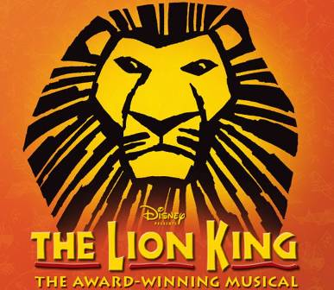
We are relying on financial support from parents to run this valuable trip. If you do secure a ticket for the show please note that payment must be made by Tuesday 4th July.

Yours sincerely

Tina Georgiades
Assistant Headteacher EYFS/UKS2
……………………………………………………………………………………………………………………………………...
Y4 & Y5 The Lion King Musical Trip

I am registering my interest in the above trip for my child ………………………………………… in

…………………………………..Class to attend The Lion King Musical trip on Wednesday 5th July 2017.

I will collect my child at 5:45pm

I give permission for my child to go home alone at 5:45pm

I understand that I will be contacted on Monday 3rd July if I have been successful in securing a ticket

Parent/carer name:…………………………………… Contact Number:…………………………….....

Signed:……………………………………………….. Date:………………………………………….……

